**BLINKIT ONLINE GROCERY MALL ANALYSIS**

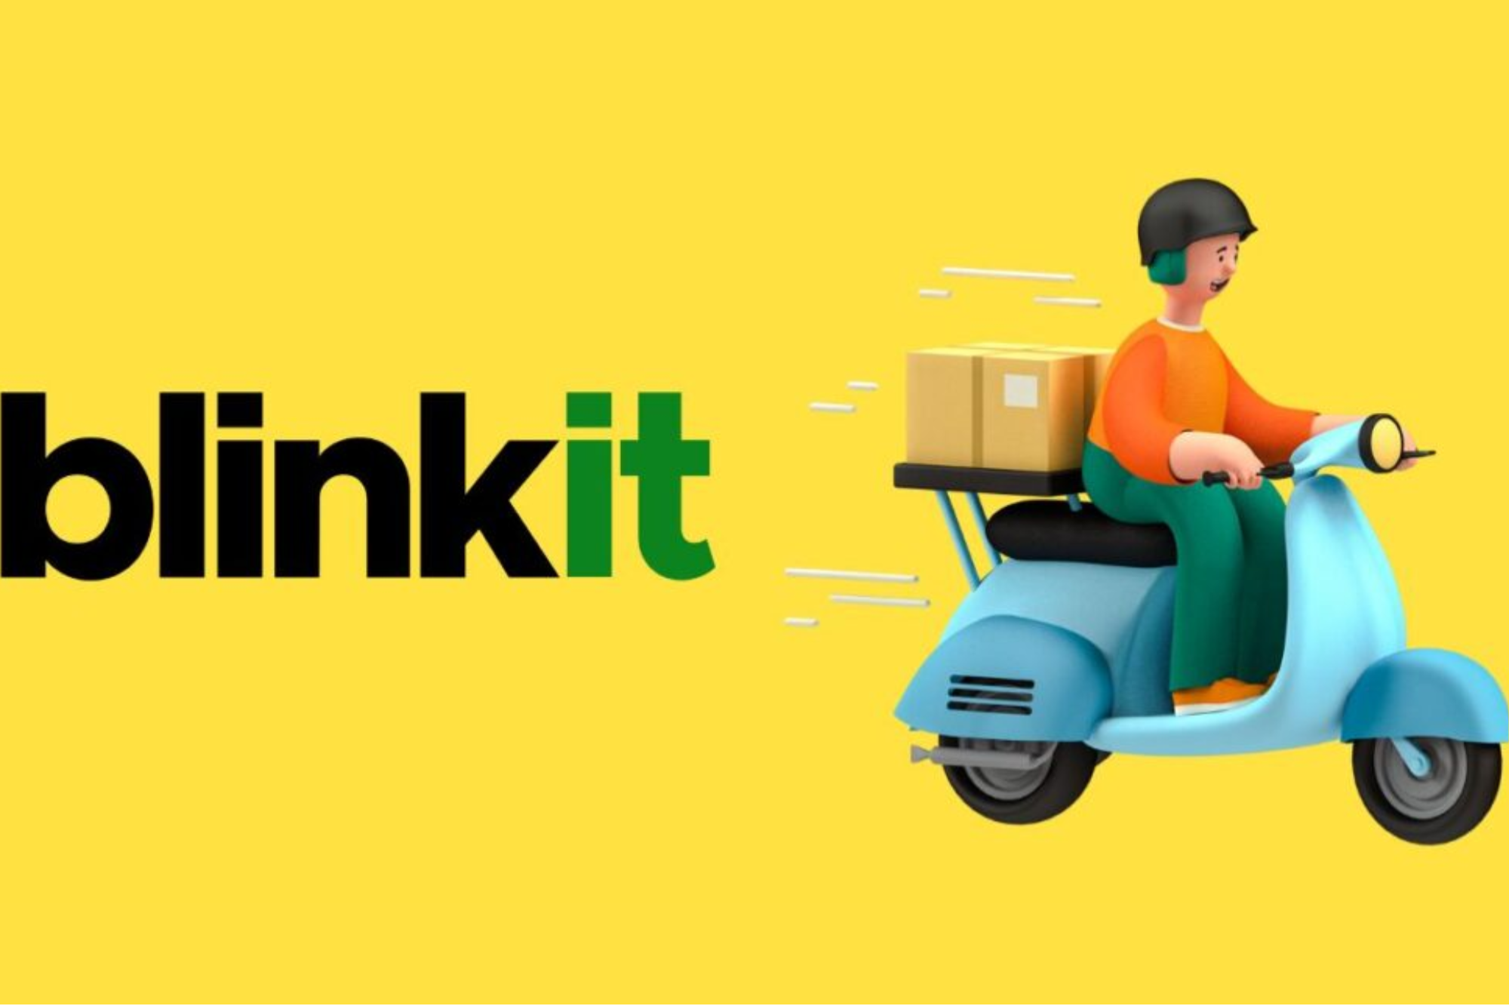

**Data Analyst: Ukonu Ugo**  
**Organization: BLINKIT**  
**Date: APRIL 2025**

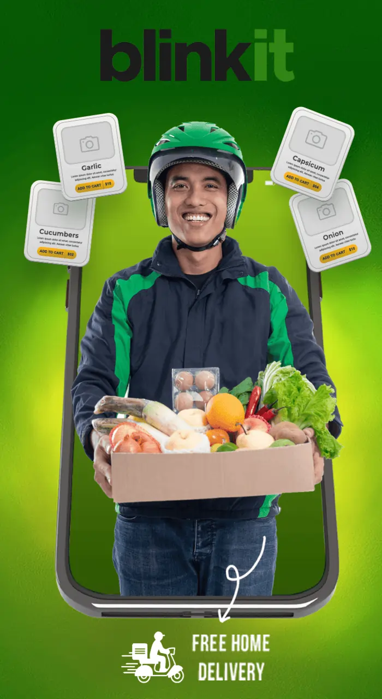

***BLINKIT ONLINE GROCERY MALL ANALYSIS***

*Trends, Insights and Recommendation*

**Abstract**

**Summary**

This contains a full process documentation of **blinkit online grocery mall analysis between March 2023 and November 2024, essence** is to provides valuable insights into customer purchasing behaviours, product demand, revenue trends, and sales performance over time.

**Objectives**

* To identify customer purchasing behaviors.
* To analyze sales performance over time.
* To identify top performing Brands.

**Methodology**

**Data Collection & Cleaning:** merged multiple datasets, handle missing values, and standardized formatting.

**Data Analysis:** Identify customer purchasing behaviors, most ordered products and performing brands.

**Dashboard Development:** Create an interactive Excel dashboard with visual elements (pivot tables, charts, slicers).

**Findings & Recommendations:** Highlighting top order channel, frequent used payment method, and actionable solutions for positive customer’s feedback.

**Key Findings/Insights**

* R**egions like the Southern, Northern and Eastern part of India has the most customers.**
* Brands like Upaal Group and Roy-Char made it to top brands by revenue.
* Snacks, Pet care and pharmaceutical products are the most ordered product category.

**Conclusions**

Findings and insights from this project will help Blinkit Online Grocery Mall to make shopping seamless for customers, improve delivery performance and increase rating

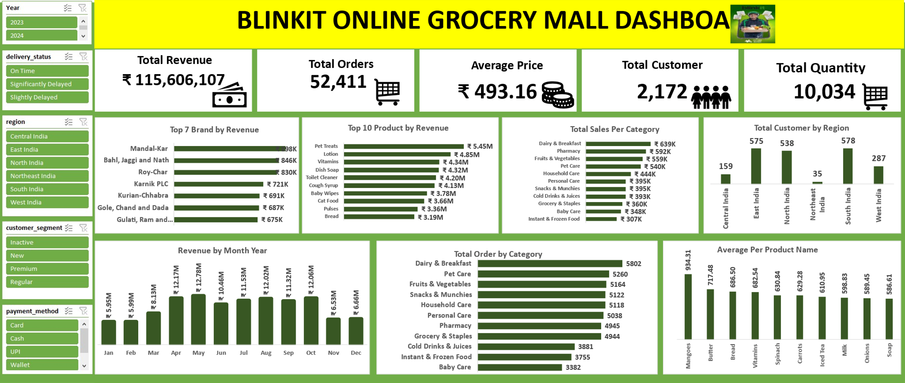

**Introduction**

**Background Study**

Blinkit is an Indian quick-commerce service i.e., an instant online delivery service that offers a wide range of products, including groceries, fresh fruits and vegetables, bakery items, meats and seafood, cosmetics, electronics, and baby care products. Founded by Albinder Dhindsa and Saurabh Kumar in December 2013 at Gurgaon, Haryana, India. It was formerly known as Grofers until 2021 when it was renamed Blinkit. (Yuvaank, 2025)

**Problem Statement**

1. How can we identify customer purchasing behaviors?
2. What method is best to analyze sales performance over time?
3. Which approach is best in identifying top Brands?

**Project Objectives**

1. To identify customer purchasing behaviors.
2. To analyze sales performance over time.
3. To identify top performing Brands.

**Data Description**

I extracted a subset of data from (Kaggle, n.d.). I utilized MYSQL query to give answers to my problem statement, which I used to generate my visuals for full understanding. The following is a description of the datasets from Kaggle;

1. Blinkit Orders Table has information of the order process take with 5,000 rows and 9 columns. Below is the column description;

* Order ID: a unique identification number of each order placed by customer.
* Customer ID: a number that is specific to each customer i.e., customer personal identifier.
* Order date: contains records of dates when the order was placed.
* Promise delivery time: timestamp of when customer supposed to receive their order.
* Actual delivery time: timestamp of when customer received their orders.
* Order total: total order sales placed by each customer.
* Payment method: includes the type of payment used to make the order purchase.
* Delivery partner ID: personal identifier of the delivery man.
* Store ID: number identifier of store that has stock of the product ordered.

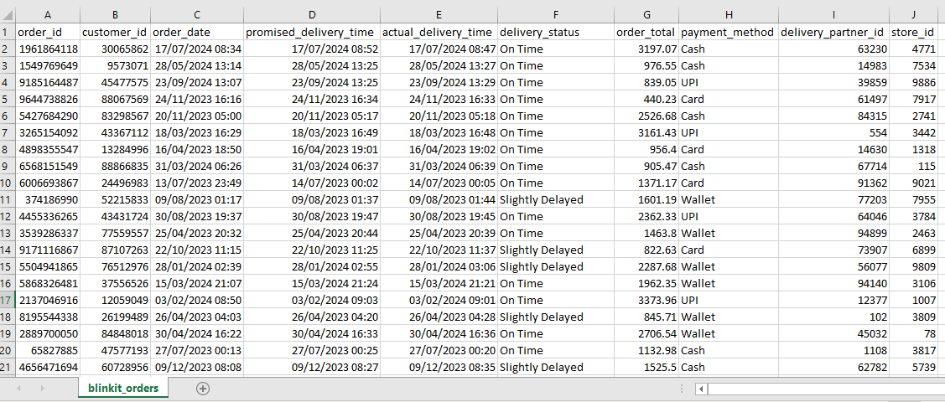

1. **Blinkit Order Item table** has 5,000 rows and 4 columns below is the description;

* Order ID: a unique identification number of each order placed by customer.
* Product ID: a unique identifier for each product on display.
* Quantity: number of quantities of product purchased.
* Unit price: selling price of each product.

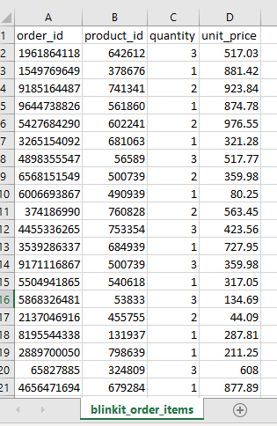

1. **Blinkit Customer Table** contains customer full information contains 2,500 rows and 13 columns. The following shows column description of the table;

* Customer ID: a number that is specific to each customer i.e., customer personal identifier.
* Customer name: customer’s full name.
* Email: customer’s email address.
* Phone: customer’s phone number.
* Address: customer’s contact/ residential address.
* Area: customer’s town/ city of resident.
* Region: customer’s regional area.
* Country: customer’s country of residence.
* Pin code: geographical location such as cities, town or village postal index number.
* Registration date: date when customer signed up on the app.
* Customer segment: information to show if a customer is new, regular or inconsistent one.
* Total orders: total number of orders placed by each customer.
* Average order value: average of each order by per customer.

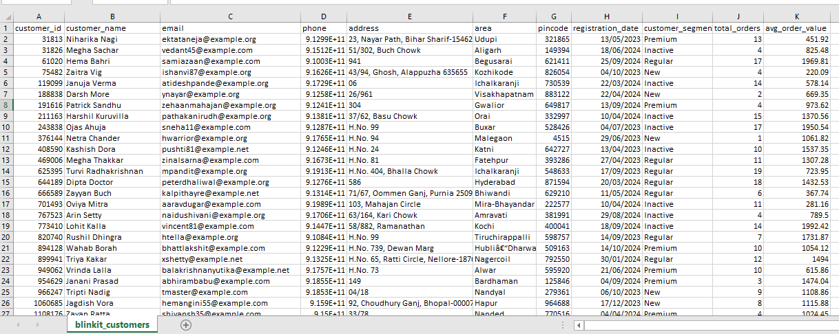

4.**Blinkit Product table** has information relating to the product with 268 rows and 9 columns. Each column contains the following description;

* Product ID: a unique identifier for each product on display.
* Product name: name of the product on display.
* Category: grouped the product name into categories of home and lifestyle.
* Brand: name of the brand that has affiliation with the product.
* Price: price tag of each product on display.
* Margin percentage: shows the percentage of profit made.
* Shelf life: information about length of time a product is safe for usage.
* Min stock level: least number of product inventory available.
* Max stock level: highest number of product inventory available.

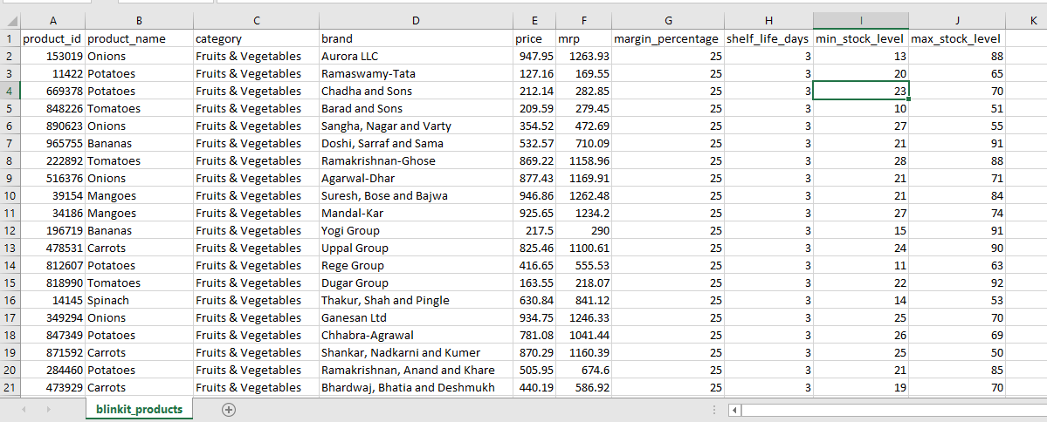

With MYSQL server, I combined the four tables using SQL query to create one with only the required columns and not allowing null to remove rows with missing values.

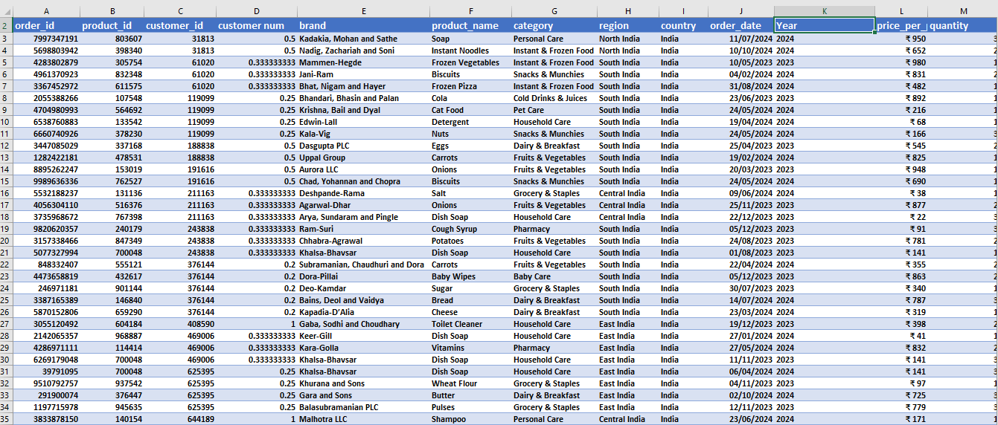

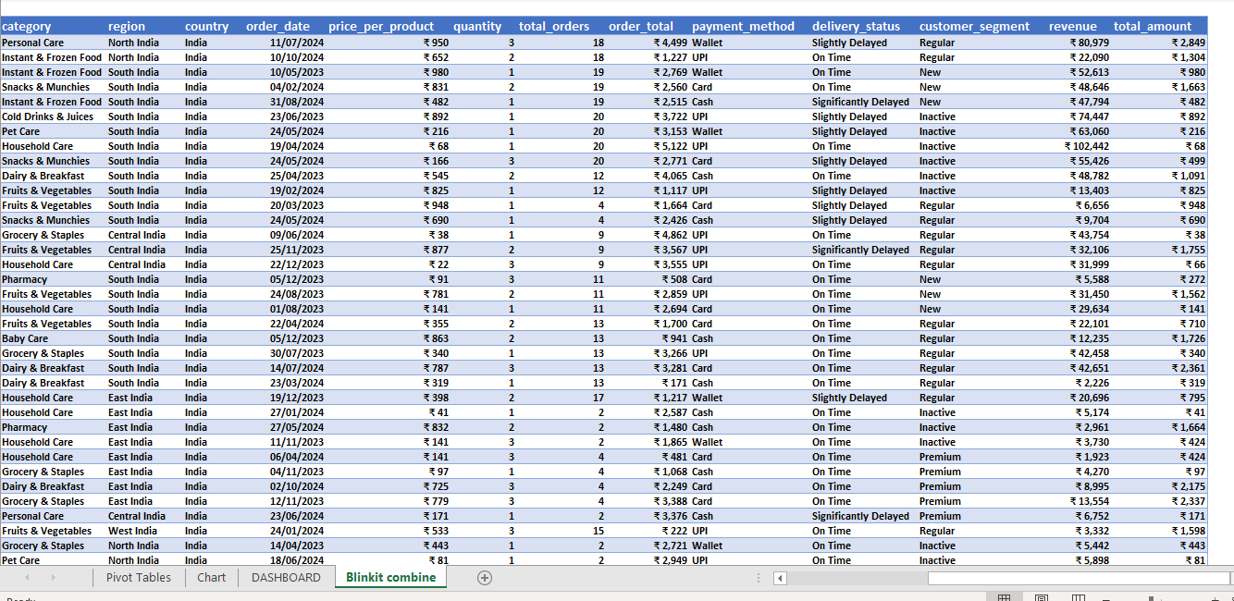

### **Methodology**

Generated tables and views to answer key questions with MYSQL and then exported to MS Excel to created visuals to display key insights.

Added a calculated column for;

* Revenue: sum total order and order total.
* Total sales: sum quantity and price.
* Customer num: in order to get the distinct total number of customers, divided 1 by COUNTIF formular eg. =1/COUNTIF(C2:C5001,C2).
* Year: extracted the year from order date.

### **Analysis**

After getting my data ready for analysis, I used the pivot table, charts and slicers to give a comprehensive insight.

**Total Sales Per Category**

Below images gives a clear visual of total sales(quantity*price) generated by each category. Instant &frozen food and Baby care is the least purchase category while Dairy&Breakfast and pharmaceutical product is the top shopped product category.

|  |  |
| --- | --- |
| **Row Labels** | **Total_sales per Category** |
| Instant & Frozen Food | ₹ 307K |
| Baby Care | ₹ 348K |
| Grocery & Staples | ₹ 360K |
| Cold Drinks & Juices | ₹ 393K |
| Snacks & Munchies | ₹ 395K |
| Personal Care | ₹ 395K |
| Household Care | ₹ 444K |
| Pet Care | ₹ 540K |
| Fruits & Vegetables | ₹ 559K |
| Pharmacy | ₹ 592K |
| Dairy & Breakfast | ₹ 639K |
| **Grand Total** | **₹ 4,972,415** |
|  |  |

**Top 7 Brand by Revenue**

Blinkit display series of product from a total of 167 brands. I ranked to show top 7 performing brands by revenue generated by each brand. Mandal-Kar, Roy-Char, etc. made it to the list.

|  |  |
| --- | --- |
| **Row Labels** | **Revenue per Brand** |
| Gulati, Ram and Sarkar | ₹ 675K |
| Gole, Chand and Dada | ₹ 687K |
| Kurian-Chhabra | ₹ 691K |
| Karnik PLC | ₹ 721K |
| Roy-Char | ₹ 830K |
| Bahl, Jaggi and Nath | ₹ 846K |
| Mandal-Kar | ₹ 898K |
| **Grand Total** | **₹ 5,348,113.46** |

**Total Customer by Region**

The Northeast and Central part of the country has the least customer base while the South and East region of the country has the highest customer. This analysis is conducted by counting number of customers using their customer ID.

|  |  |
| --- | --- |
| **Row Labels** | **Sum of customer num** |
| Central India | 159 |
| East India | 575 |
| North India | 538 |
| Northeast India | 35 |
| South India | 578 |
| West India | 287 |
| **Grand Total** | **2172** |

**Total Order by Category**

Dairy & Breakfast and Pet Care is the most shopped product category with 5,802 and 5,260 total orders placed while Instant & Frozen and Baby Care recorded the least number of orders placed at 3,755 and 3,382.

|  |  |
| --- | --- |
| **Row Labels** | **Sum Total_orders** |
| Baby Care | 3382 |
| Cold Drinks & Juices | 3881 |
| Dairy & Breakfast | 5802 |
| Fruits & Vegetables | 5164 |
| Grocery & Staples | 4944 |
| Household Care | 5118 |
| Instant & Frozen Food | 3755 |
| Personal Care | 5038 |
| Pet Care | 5260 |
| Pharmacy | 4945 |
| Snacks & Munchies | 5122 |
| **Grand Total** | **52,411** |

**Revenue by Month Year**

Information on this record has a date stamp between 17-03-2023 and 04-11-2024. **2023** generated **a** sum of **₹56,969,071** with **December 10 2023** as peak day sales at **₹ 516,060.87** and **December** as peak sales month at **₹6,655,166. 2024** generated a sum of **₹58,637,036** with **April 15 2024** as peak day sale at **₹545,187.17** and April as peak month sales at **₹ 6,198,086** making it a total of **₹115,606,107** in revenue for both years.

|  |  |
| --- | --- |
| Revenue by MonthYear | |
| **Row Labels** | **Sum of revenue** |
| Jan | ₹ 5,947,881 |
| Feb | ₹ 5,989,625 |
| Mar | ₹ 8,131,232 |
| Apr | ₹ 12,172,171 |
| May | ₹ 12,783,256 |
| Jun | ₹ 10,464,720 |
| Jul | ₹ 11,534,603 |
| Aug | ₹ 12,015,885 |
| Sep | ₹ 11,318,108 |
| Oct | ₹ 12,059,519 |
| Nov | ₹ 6,533,939 |
| Dec | ₹ 6,655,166 |
| **Grand Total** | **₹ 115,606,107** |

**Top 10 Product by Revenue**

Blinkit have a total of **51** kinds of product on display. Images below showed top 10 most shopped product as **Pet Treats** **ranked at number 1** and **Bread** **at the 10th position** with revenue of **₹5,447,324** and **₹3,194,216** respectively.

|  |  |
| --- | --- |
| **Row Labels** | **Sum of revenue** |
| Bread | ₹ 3.19M |
| Pulses | ₹ 3.36M |
| Cat Food | ₹ 3.66M |
| Baby Wipes | ₹ 3.78M |
| Cough Syrup | ₹ 4.13M |
| Toilet Cleaner | ₹ 4.20M |
| Dish Soap | ₹ 4.32M |
| Vitamins | ₹ 4.34M |
| Lotion | ₹ 4.85M |
| Pet Treats | ₹ 5.45M |
| **Grand Total** | **₹ 41,277,517** |

**Average Per Product Name**

The average price of the total 51 product is **₹493.16**.products like **Mango**, **Butter** and **Bread** have the highest average price at **₹934.31, ₹717.48** and **₹687** respectively. Filtered to show top 10 highest average price of each product.

|  |  |
| --- | --- |
| **Row Labels** | **Average of price_per_product** |
| Mangoes | 934.31 |
| Butter | 717.48 |
| Bread | 686.50 |
| Vitamins | 682.54 |
| Spinach | 630.84 |
| Carrots | 629.28 |
| Iced Tea | 610.95 |
| Milk | 598.83 |
| Onions | 589.45 |
| Soap | 586.61 |
| **Grand Total** | **663.08** |

**Slicers**

These slicers will help filter my findings to give more insights on revenue and total order of the following table categories;

**Delivery Status**

|  |  |  |
| --- | --- | --- |
| **Delivery Status** | **Revenue** | **Total Orders** |
| 1. **On time** | **₹ 76,465,366** | **36,096** |
| 1. **Significantly delayed** | **₹ 11,466,506** | **5,119** |
| 1. **Slightly delayed** | **₹ 24,674,235** | **11,196** |

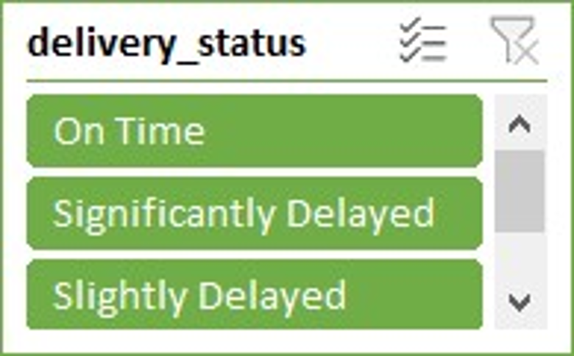

**Region**

|  |  |  |
| --- | --- | --- |
| **Region** | **Revenue** | **Total Orders** |
| 1. **Central India** | **₹ 8,695,254** | **3,863** |
| 1. **East India** | **₹ 28,790,003** | **13,342** |
| 1. **North India** | **₹ 28,131,104** | **12,932** |
| 1. **Northeast India** | **₹ 1,907,768** | **757** |
| 1. **South India** | **₹ 32,644,894** | **14,873** |
| 1. **West India** | **₹ 15,437,084** | **6,644** |

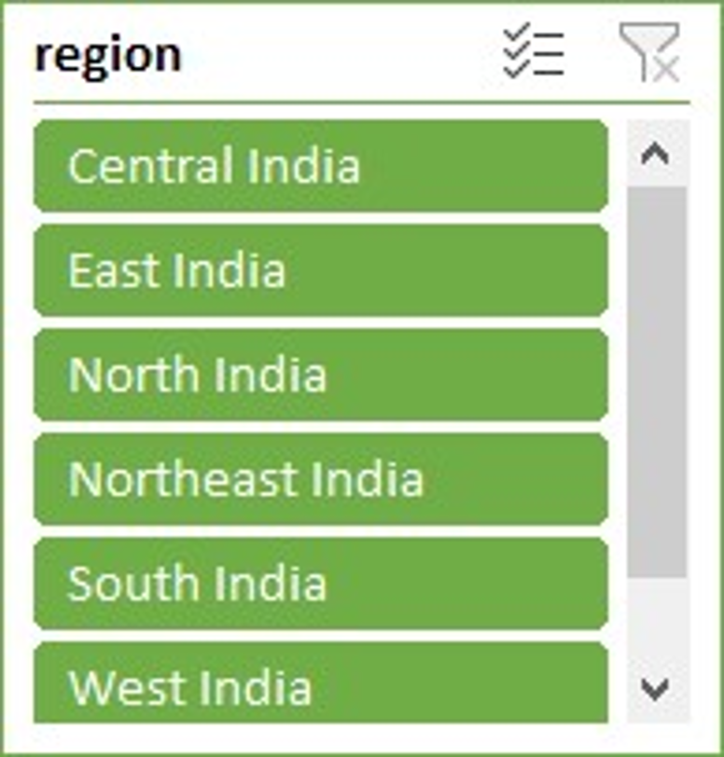

**Customer Segment**

|  |  |  |
| --- | --- | --- |
| **Customer** | **Revenue** | **Total Orders** |
| 1. **Inactive** | **₹ 27,540,873** | **12,562** |
| 1. **New** | **₹ 30,154,909** | **13,189** |
| 1. **Premium** | **₹ 28,036,830** | **13,019** |
| 1. **Regular** | **₹ 29,873,495** | **13,641** |

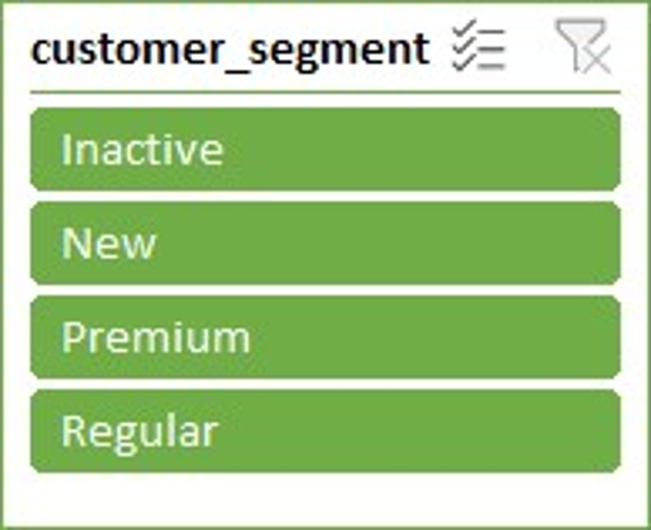

**Payment Method**

|  |  |  |
| --- | --- | --- |
| **Payment** | **Revenue** | **Total Orders** |
| 1. **Card** | **₹ 30,154,152** | **13,381** |
| 1. **Cash** | **₹ 29,644,254** | **13,237** |
| 1. **UPI (Unified Payment Interface)** | **₹ 27,621,059** | **12,769** |
| 1. **Wallet** | **₹ 28,320,642** | **13,024** |

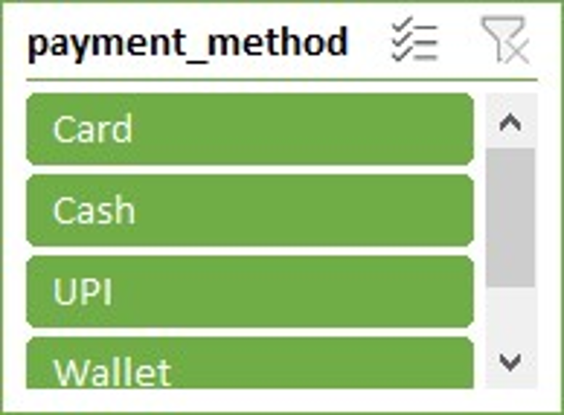

**Key Performance Indicator**

|  |  |
| --- | --- |
| **Total Revenue** | **₹ 115,606,107** |
|  |  |
| **Total Order** | **52,411** |
|  |  |
| **Total Quantity** | **10,034** |
|  |  |
| **Average Price** | **₹ 493.16** |
|  |  |
| **Total customer** | **2,172** |



### **Key Findings/ Insights from Analysis**

1. Revenue generated is at **₹115,606,107** while a total of **52,411** orders was placed in both years.
2. **5,000** customer was accounted with a sum total of **10,034** of product soldin quantity.
3. the **South** and **East** region of the country has the highest customer
4. **2023** generated **a** sum of **₹56,969,071** while **2024** generated a sum of **₹58,637,036** in total.
5. Promised delivery time is at record of **69%.**
6. **Newly** signed up customers generated the most revenue while **Regular** customer placed the highest orders.
7. **Card** is the widely used means of payment.

## **Recommendations**

1. Time to time app update to add new features to ensure user-friendly interface for a seamless shopping experience for all customers.
2. Blinkit should partner with a popular influencer and a lunch a campaign through online and offline ads to create more awareness about blinkit services especially those in the Northeast and Central part of the country with the least customer base.
3. Blinkit should implement a loyalty program to retain more customer while encouraging most orders.
4. Blinkit should from time to time run a promo sale while focusing more in regions with low turn in.
5. Feedbacks and reviews should be taken serious cause it gives room for improvement and overall experience.
6. Collaborate with courier services to ensure reliability, flexibility, delivery efficiency and product security.

**Conclusion**

Essence of this project is to help Blinkit stakeholder understand customer’s behaviour, purchasing power and seasonal variations in online grocery shopping. With this interactive dashboard and insights, Blinkit stakeholder can take a proactive measure to ensure that shoppers have a seamless shopping experience.